Project Design Phase
Solution Architecture

Date | 15 February 2025
Team ID | LTVIP2026TMIDS73770
Project Name | Freelancefinder: Discovering Opportunities, Unlocking Potential
Maximum Marks | 4 Marks

Solution Architecture:
Solution architecture for ShopEZ defines how the platform will function end-to-end by connecting users, sellers, payment systems, and logistics to create a smooth online shopping experience. It ensures reliability, security, and scalability of the entire application.
Its goals are to:
- Provide a unified and efficient platform for online shopping across multiple product categories.
- Describe the structure, components, data flow, and interactions between frontend, backend, database, and external services.
- Define the major features such as product search, price comparison, order management, secure payments, and user personalization.
- Ensure the system is scalable, secure, and capable of handling a large number of users and transactions.
- Provide clear specifications so development teams can build, test, deploy, and maintain the solution effectively.
Example - Solution Architecture Diagram:

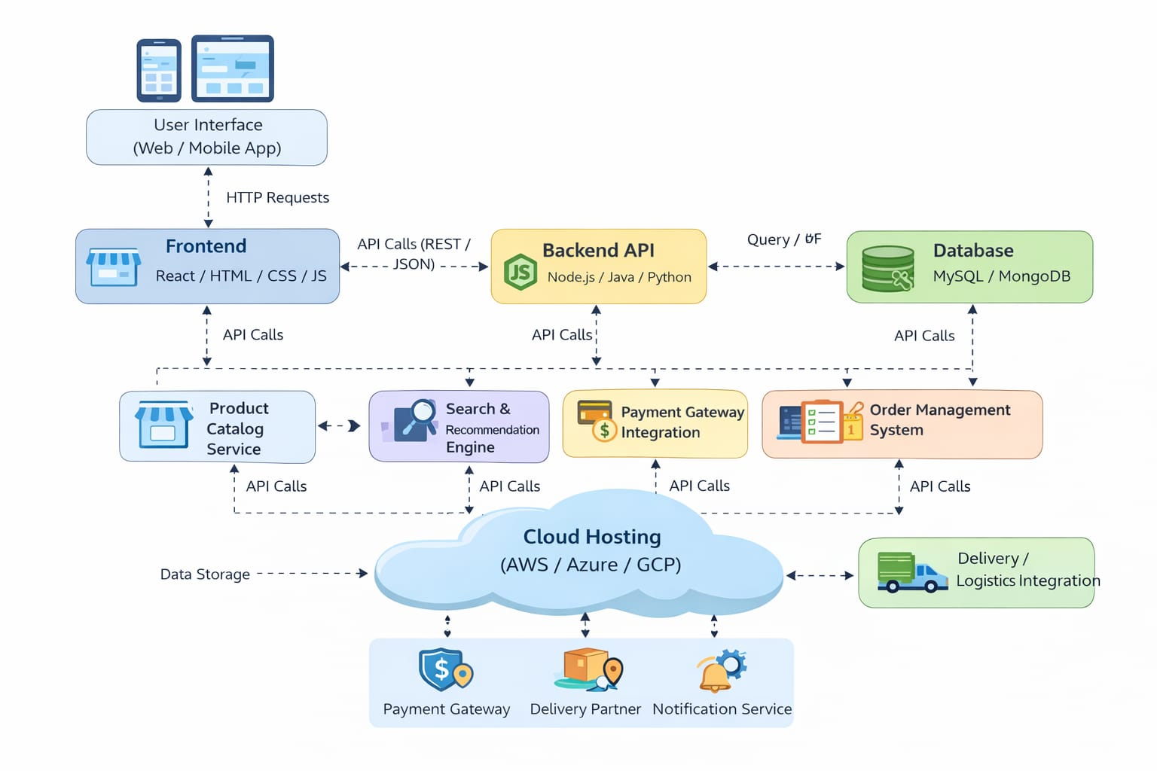
Figure 1: Architecture and data flow of the voice patient diary sample application
Reference: https://aws.amazon.com/blogs/industries/voice-applications-in-clinical-research-powered-by-ai-on-aws-part-1-architecture-and-design-considerations/

